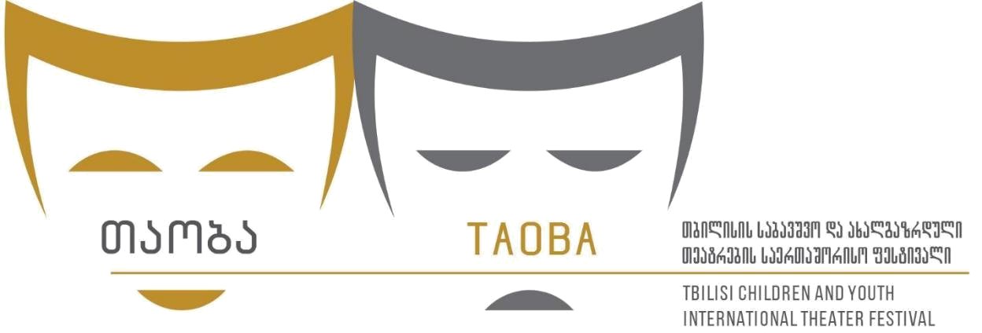

5th TBILISI CHILDREN AND TOUTH INTERNATIONAL THEATRE FESTIVAL

1-5 June 2025
You are invited to take part in 5th edition of the Festival
In case of selection of your production festival will cover all your local expenses /accommodation, meal and airport transfers, stage assistance/
Festival not cover international travel and fees.
We are hope on your interest and willing to cooperate
With best regards
Festival team

APPLICATION FORM (Deadline 20 April 2025)

COMPANY INFORMATION

Company Name:

Company web address:

Country:

Address:

Phone/What’s Up:

E-mail:

Contact Person (his/her position): Nikolett Németh, dramaturg

Brief Company History:

PERFORMANCE DETAILS

Performance/Play Name:

Playwright:

Director:

Designers (decor, costume, light, music, choreography…):
Brief description of the performance: ( Synopsis)

Age range:
Primary discipline:
Language:
Duration:
Cast list of the performance:
Actors:
Total number of the group:
Names and duties of the members of the theater that will come to the festival:

- Does your performance have special requirements:
- Preferred dates of performance:
- Proposed venue/type of venue:
- Time required for:

- Size of required acting area:

Sound:

- Record of performance (Applications without full video will not be accepted)
- Photos , brochures, posters, any other supporting documentation. Please send the photos by e-mail: itigeorgia@gmail.com; info.childrentheatrefestival@gmail.com


Please access the photos here:

Trailer of the performance:

Social network: https://www.facebook.com/TCYITF

E-mail: itigeorgia@gmail.com; info.childrentheatrefestival@gmail.com

Tel/Whats Up + : +995 595305000
